Wool Rugs
Hello! Thanks for your interest in purchasing a rug. As stated on my website, wool rugs are durable and should last you through years of use. I put a nonslip backing on each rug to make it even more functional.

Here I am including some information to include in the message you send me to order the best piece for you.

Things to include in your message:
1. DESIGN TITLE
Scrolling over the images on my website will show you their title.

2. BORDER STYLE
Would you like your rug to have a symmetric border (i.e., Make a square or rectangular border around the rug), or would you like the rug to be in the shape of the design? Examples of both are included below. Even if you would like the rug to fit the shape of the design, I include a small border using a different color of yarn (usually white), because the edges of my rugs curve down some to hide the rug backing.

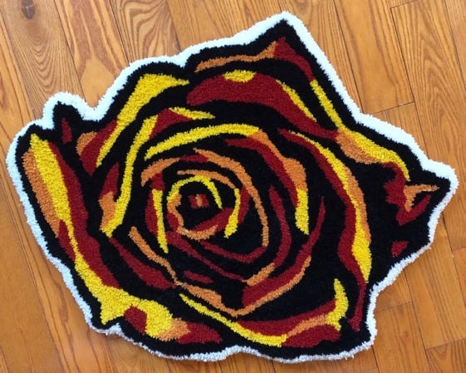
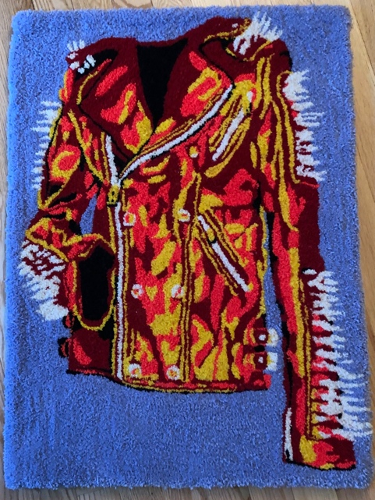

Example of a rectangular border Example of fitting the shape of the design

3. COLORS
Attached here is a list of possible colors. Use the column letter and row number to tell me what colors you are interested in. If you don’t know exact colors but have a general color scheme in mind (i.e., warm colors, cool colors, greens and yellows etc.) you can just tell me anyway you find easiest to explain it. I will always send you a mockup of the rug using the colors you choose to make sure they are to your liking! Exact colors may vary slightly, but I did my best to match the color of the yarn. It may be possible to get a wider range of colors, but that requires me to ship from stores that are generally located in Europe. This requires a wait time as colors get shipped through customs and may come with a 20-40$ shipping charge, but I am willing to work with you if you really would like a different color.

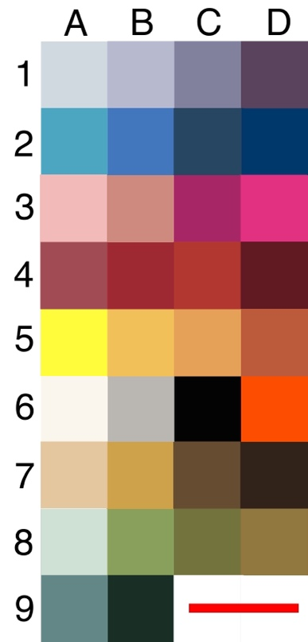

4. SIZE
The largest rug I can make using my current setup is 4.5’ x 4.5’. The more detailed the design, the bigger it has to be. For example, the rose rug that I used as an example in the section on border styles can be made fairly small, while the jacket rug I used in that same section needs to be larger to fit in all of the details. The smallest a rug with little detail can generally go is a little larger than 1’. I can more accurately tell you the sizing available once I know the design you want. As a rule of thumb, I charge 80$-85$ per square foot for wool rugs. It may be a little cheaper or a little more expensive depending on sizing and how many colors are required for the rug.

5. ANY OTHER REQUEST/COMMENT
If you want any other request beyond the information listed here, feel free to tell me and I’ll do my best to accommodate you! For example, maybe you want to have one of the designs repeat several times as a pattern on a rug. Anything different than just a straightforward replication of the design.

